# Portfolio website of A. Prinsloo

Contents

Portfolio website of A. Prinsloo 1

Description 2

Instructions on how to set up and run the project locally: 2

Dependencies and technologies used: 2

Links to live demos or hosted versions: 2

Screenshots or GIFs showcasing the project 2

Homepage 2

Projects page 4

Skills page 4

Education / Work experience page 6

Contact Information 7

References 8

## Description

This project consists of a website format of the curriculum vitae of Annalie Prinsloo to showcase her skills as a web developer. The website consists of five pages, namely a Home page, a Project page, a Skills page, an Education and Work Experience page and a Contact page.

## Instructions on how to set up and run the project locally:

Here follows the instructions to set up this website locally:

1. Install the XAMPP server and follow the instructions.
2. Add the website files in a folder named “AnnaliePrinsloo” to C:\xampp\htdocs
3. Edit The Apache "httpd.conf" Configuration File to your named folder for the "DocumentRoot" and "Directory" paths.
4. Open a browser and type: <http://localhost/Home.html>

Note: Follow the instructions given from: <https://medium.com/@amaanlari5/how-to-access-your-localhost-from-mobile-windows-and-macos-7cb7bdb4aa4f> to set up and view the website on your mobile device.

## Dependencies and technologies used:

I used the following technologies in the development of this website:

* Visual Studio Code to create the HTML, CSS and JavaScript files.
* GitHub for version control.

The website is dependent on the following technologies to function:

* EmailJS to send the form submission data to my email address.
* XAMPP, Apache and PHP to host the website locally.
* Browsers (Chrome, Firefox, Edge and Chrome on mobile device).

## Links to live demos or hosted versions:

The code for the website can be found on GitHub at: <https://github.com/AnnaliePrinsloo1/AnnaliePrinsloo.git>

## Screenshots or GIFs showcasing the project

### Homepage

In the screenshot below the top of the homepage is seen with the navigation bar at the top. The navigation bar appears on each page.

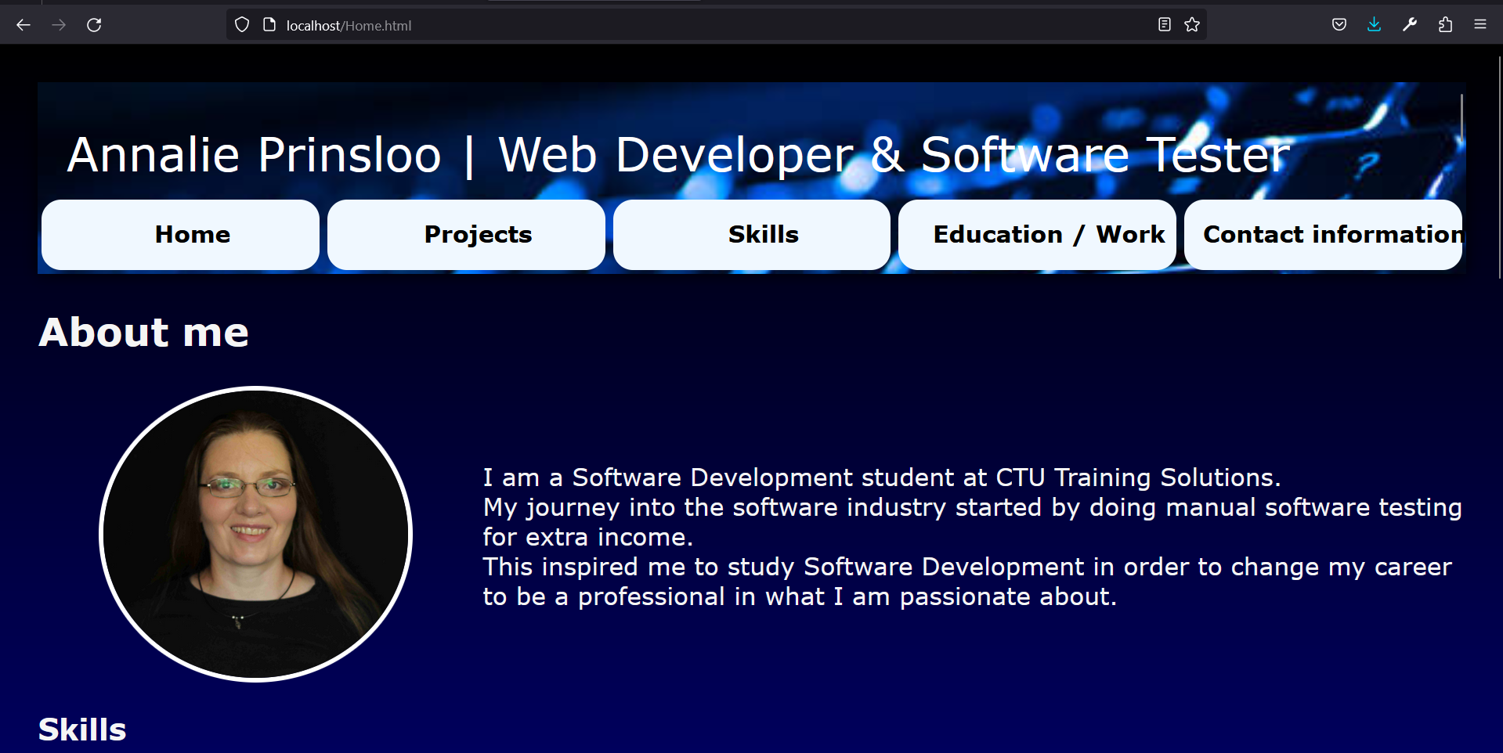

My skills are listed on the home page if one scrolls down:

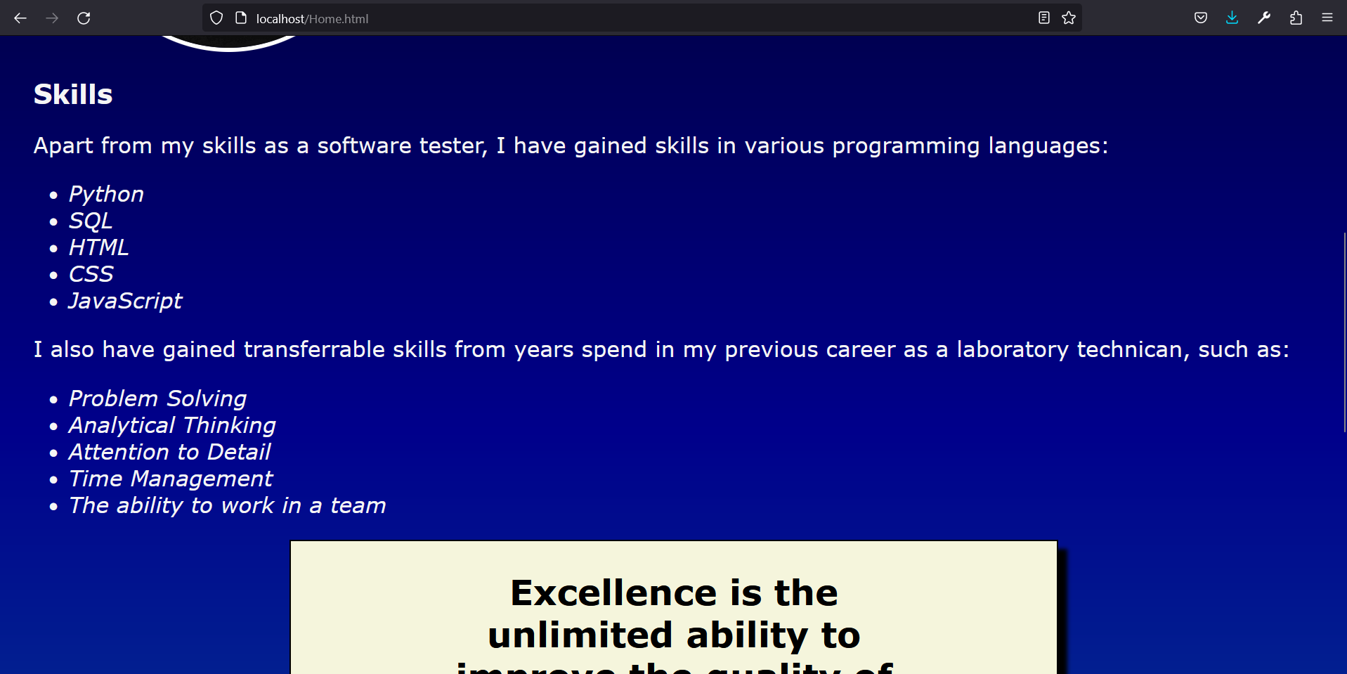

A blockquote is also displayed:

As well as My interests at the bottom of the page with the copyright information in a footer element (with is also displayed on all the pages).

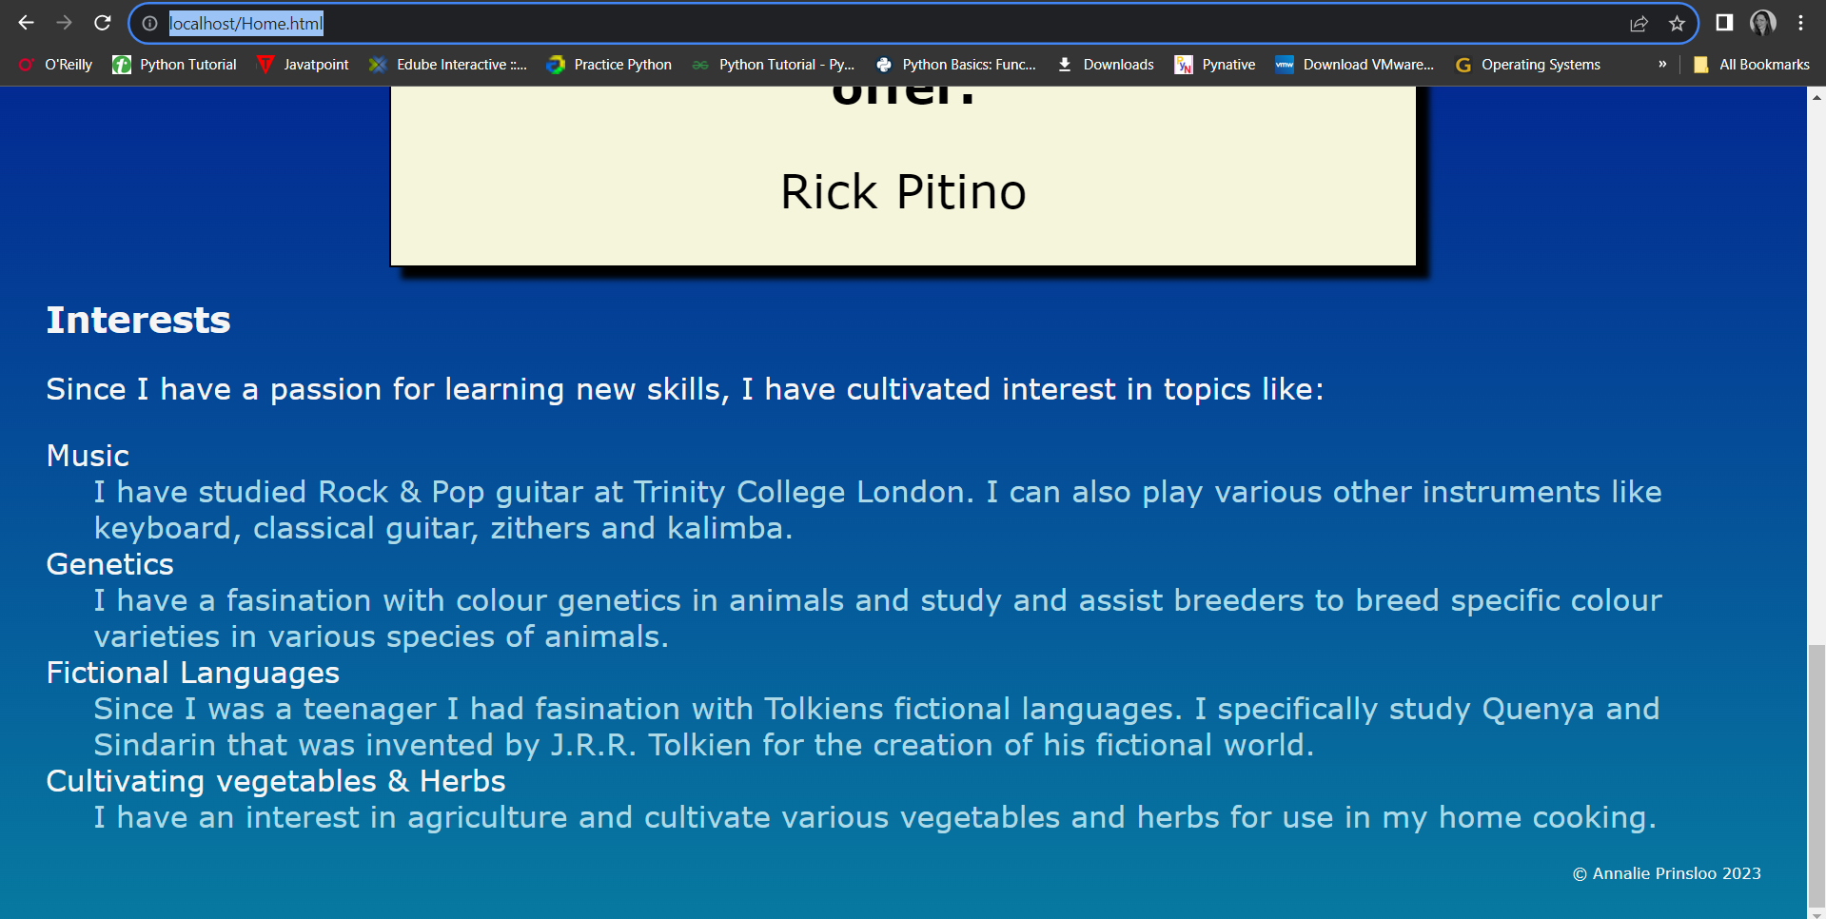

### Projects page

The projects page shows my projects with a screenshot of each project and a link to the GitHub repository of the project for the projects that contain code.

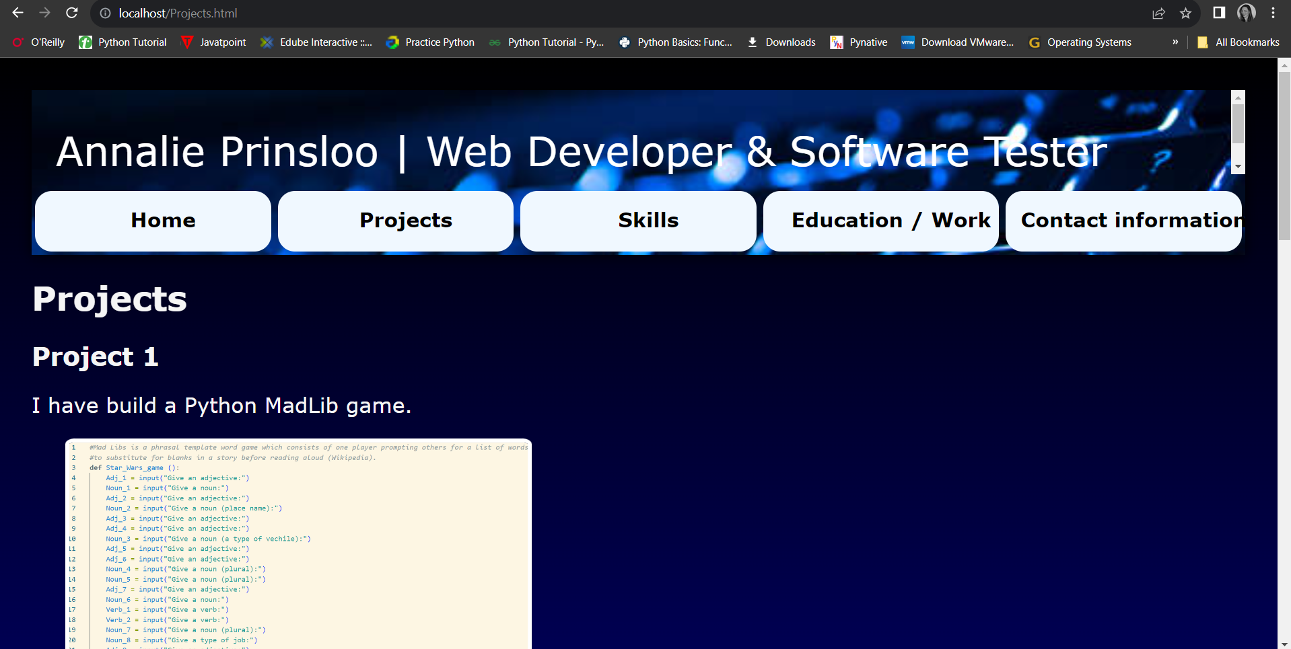

### Skills page

My technical skills are listed in a table element:

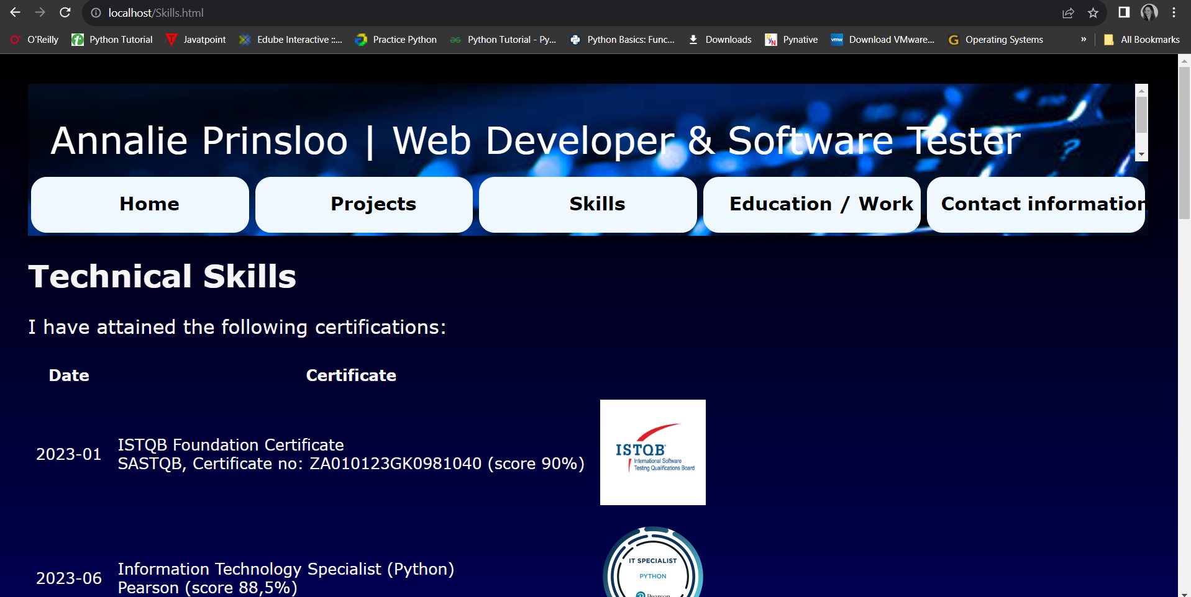

The programming languages, frameworks and tools are also listed on this page:

An animation is placed at the bottom of the page which is created with HTML and CSS (keyframes):

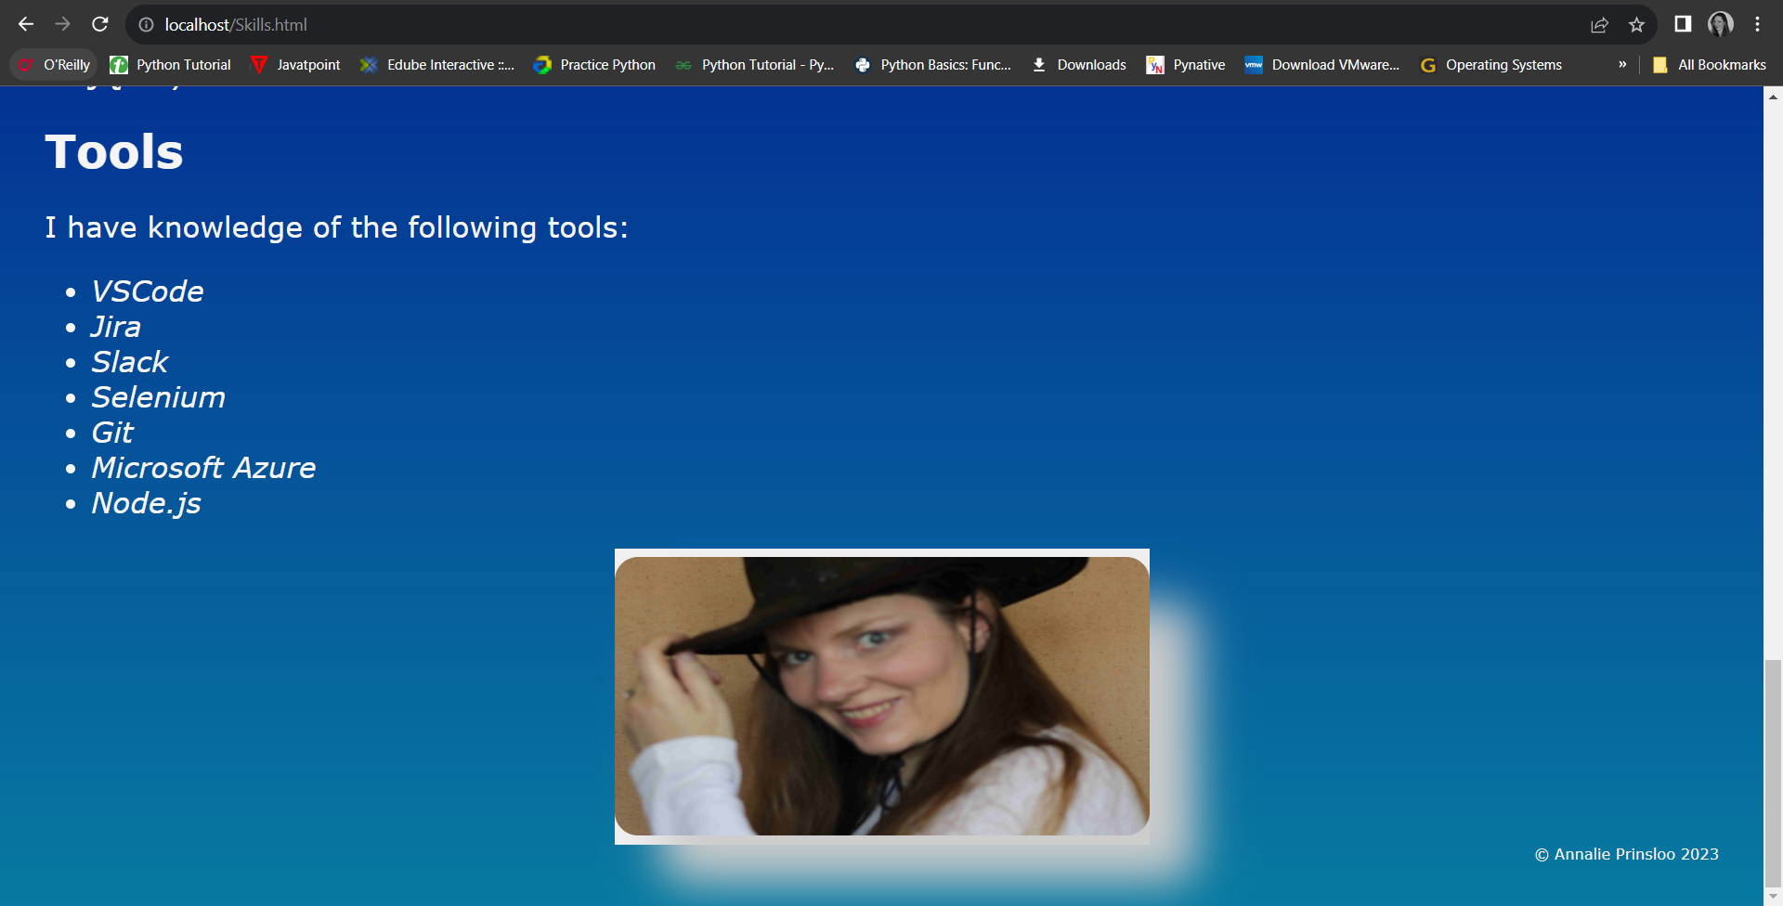

### Education / Work experience page

My education and work experience is shown on the Education / Work page.

Another animation is placed at the bottom of this page. This animation also uses HTML and CSS (keyframes):

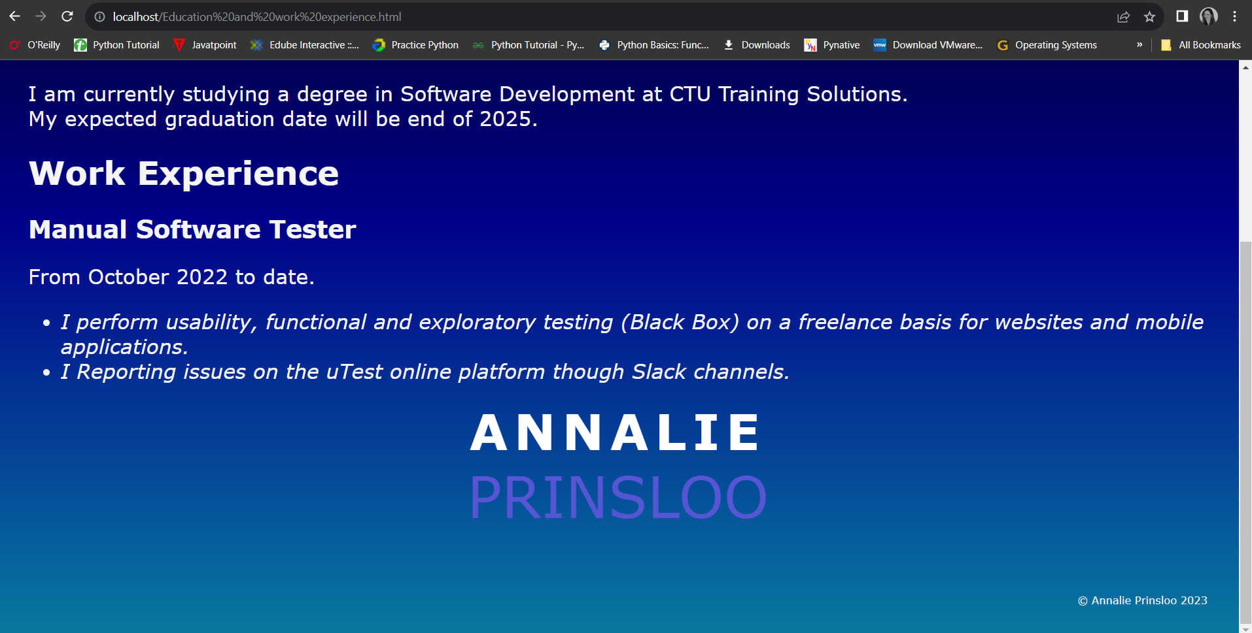

### Contact Information

A contact form is created with the HTML <form> element and the form submission is controlled by JavaScript with the dependency of the EmailJS application to send the form data to my email address.

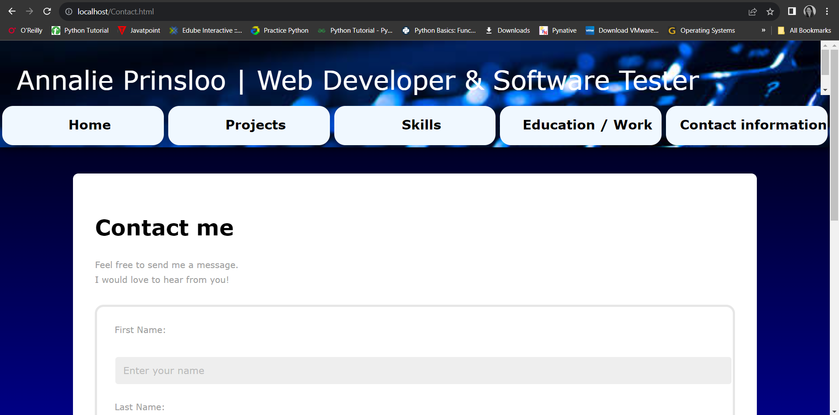

At the bottom of the page is working image links to my LinkedIn, GitHub and Gmail accounts:

For example clicking on the Gmail image takes you to outlook:

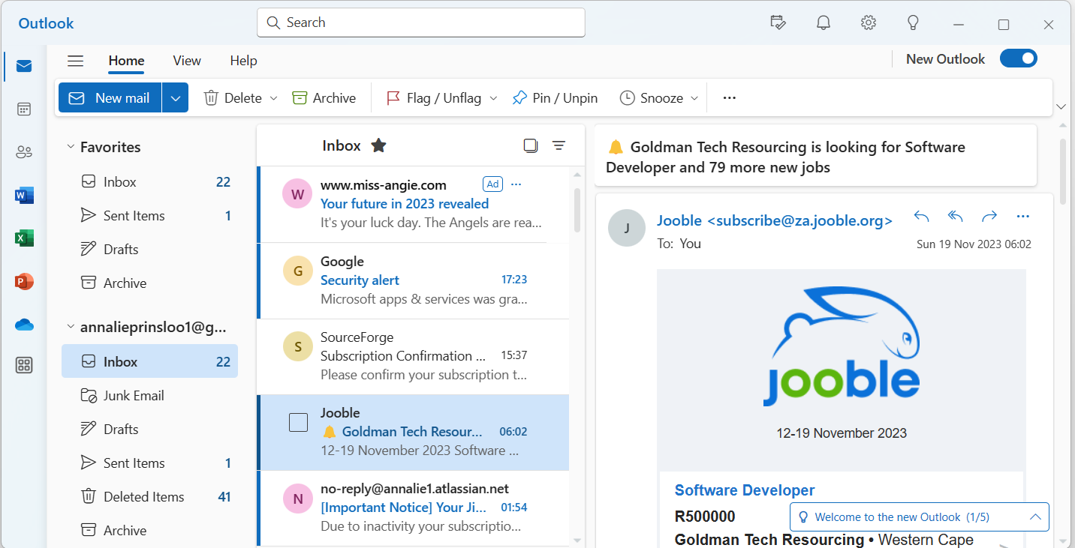

## References

1. EmailJS, 2023. Send Email Directly from Your Code. Available at: <https://www.emailjs.com/> (Accessed: 2023/11/18).
2. DarkCode. 2018. Simple Text Animation Just By Using HTML & CSS. Available at: <https://www.youtube.com/watch?v=Syg_9iB1vco&list=PLxA4Fu_DdmxZLdmOuKTur3yN7Y5-o2Nyy&index=20> (Accessed: 2023/11/18).
3. How To Host A Website On Xampp Server, no date. Entrepreneur Makeover. Available at: <https://www.entrepreneurmakeover.com/how-to-host-a-website-on-xamp-server> (Accessed: 2023/11/19).
4. Lari, A. no date. How to Access Your Localhost from Mobile: Windows and macOS. Medium. Available at: <https://medium.com/@amaanlari5/how-to-access-your-localhost-from-mobile-windows-and-macos-7cb7bdb4aa4f> (Accessed: 2023/11/19).
5. QuickCodingTuts. 2023. Build A Working Contact Form with Email JS | Quick Tutorial. Available at: <https://www.youtube.com/watch?v=qxWDVRyc95E&list=PLxA4Fu_DdmxZLdmOuKTur3yN7Y5-o2Nyy&index=19> (Accessed: 2023/11/18).